Prepare your Laptop for Devops

1. Create aws free tier account.
2. Create azure free tier account.
3. Download and install Git on windows

<https://git-scm.com/downloads/win>

#git --version

Download, install and configure java 17 on windows

1. Before downloading check, java is installed in your laptop or not. Uninstall java if the version is not 17

<https://www.oracle.com/java/technologies/javase/jdk17-archive-downloads.html>

|  |  |  |
| --- | --- | --- |
| Windows x64 MSI Installer | 152.66 MB | <https://download.oracle.com/java/17/archive/jdk-17.0.11_windows-x64_bin.msi> ([sha256](https://download.oracle.com/java/17/archive/jdk-17.0.11_windows-x64_bin.msi.sha256)) |

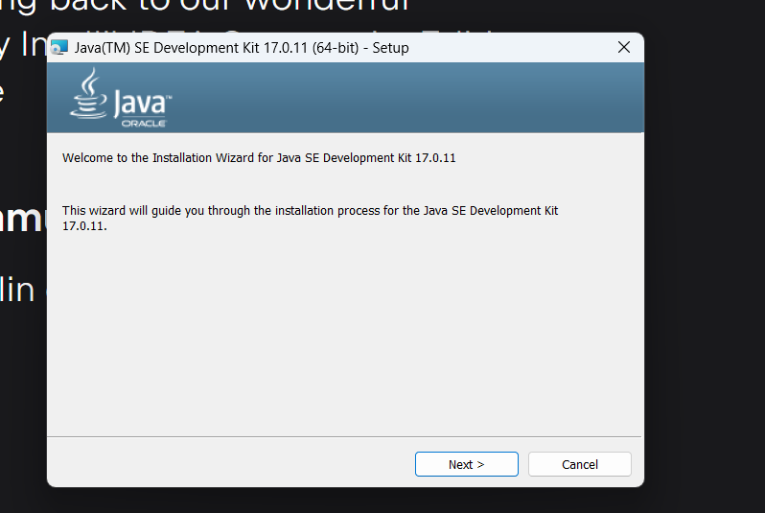

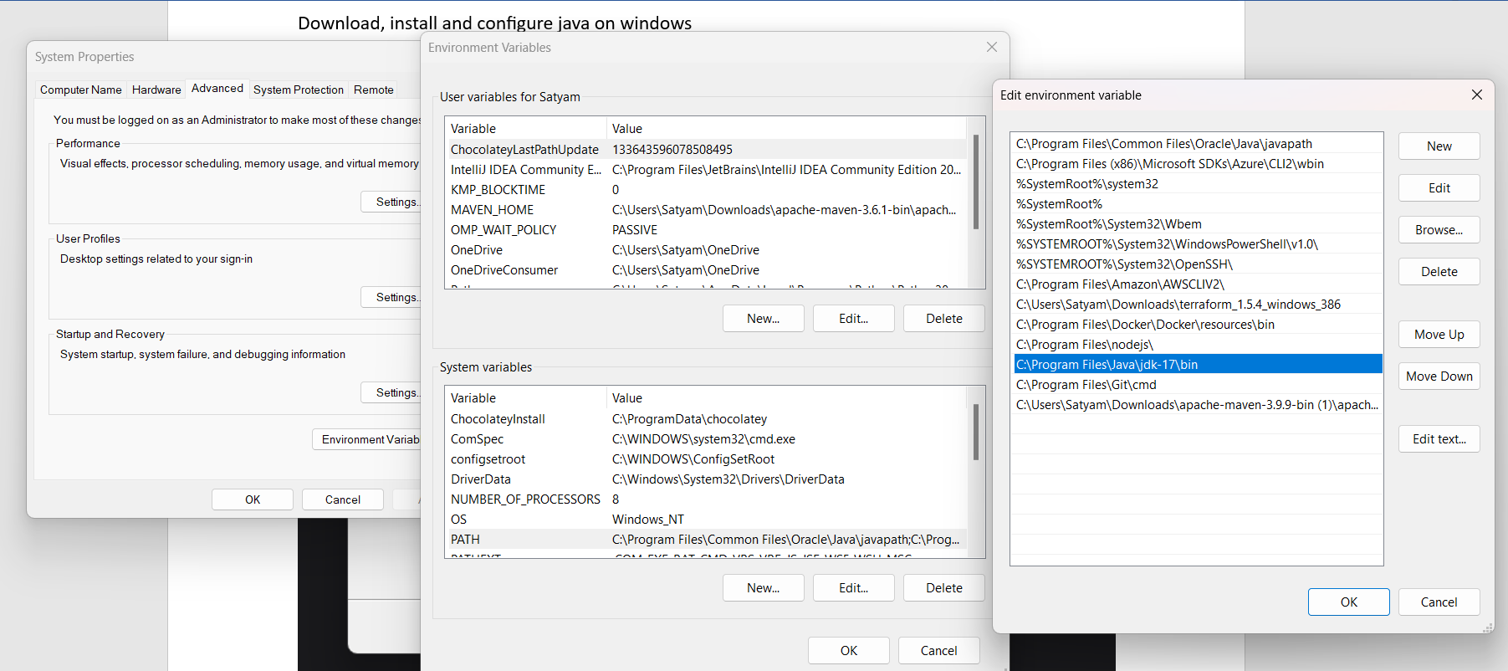

#java –version

#javac --version

Download and Configure maven on windows

<https://maven.apache.org/download.cgi>

Note : Maven is dependent on Java

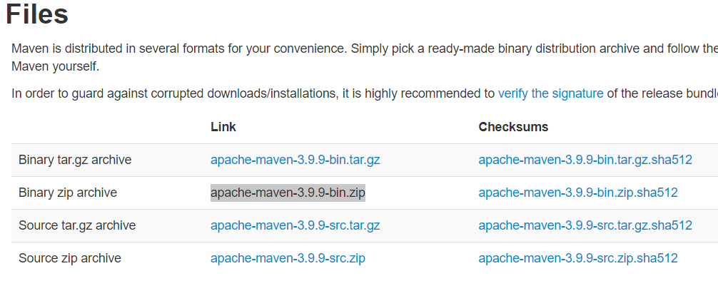

Download and Unzip the maven folder

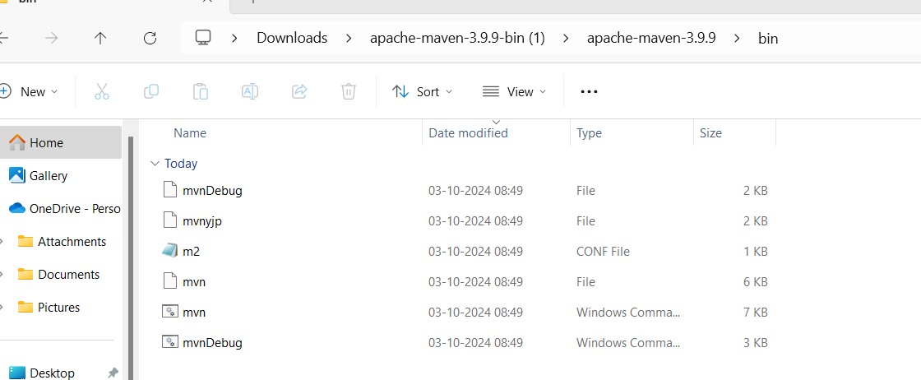

Set The System env variable for Maven

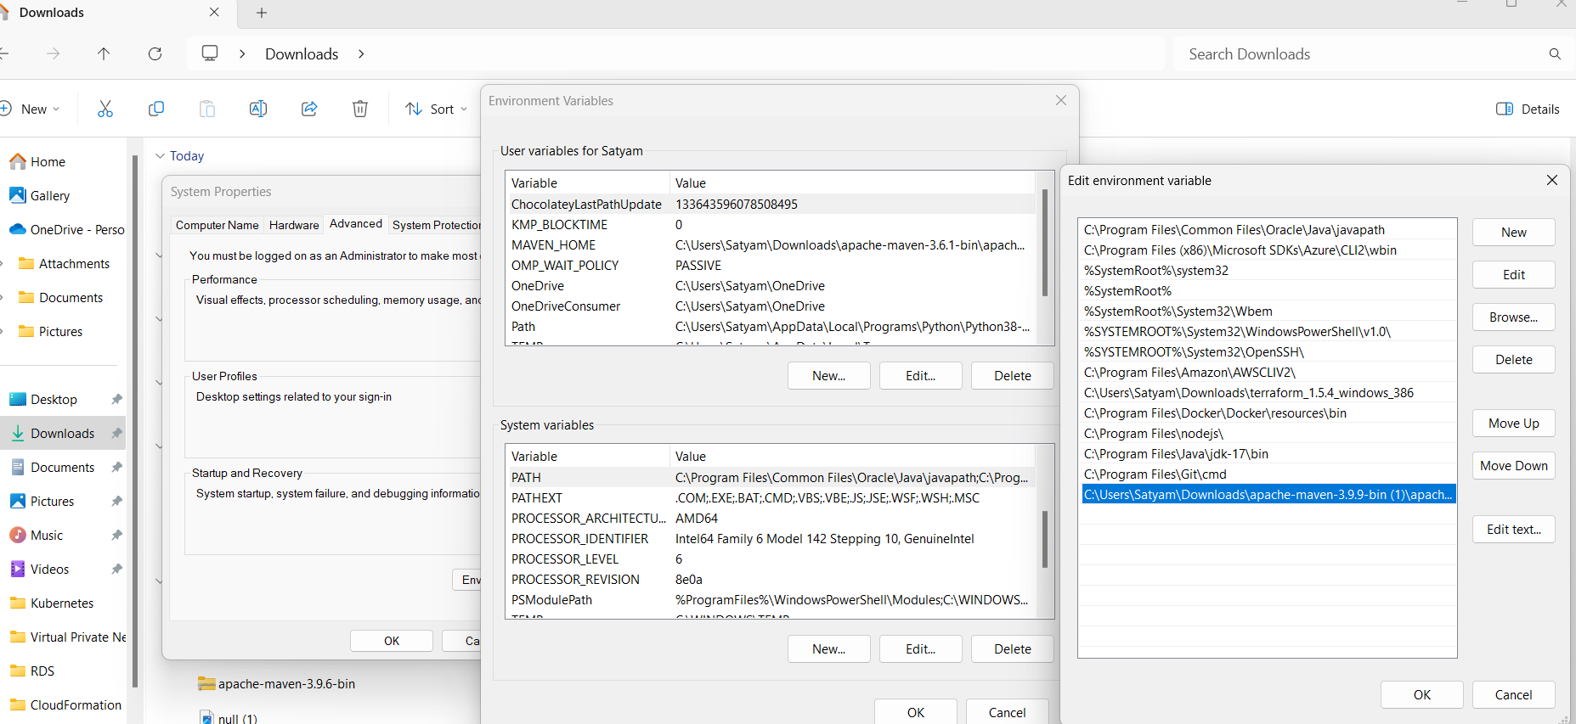

Open the command promot and run the command #mvn –version

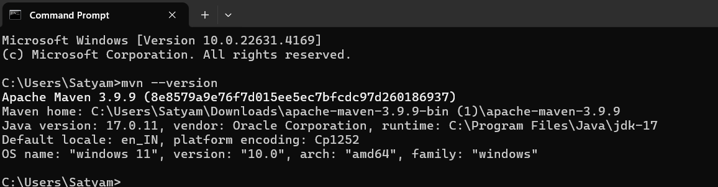

Download and install Intelli Idea Community edition

<https://www.jetbrains.com/idea/download/?section=windows>

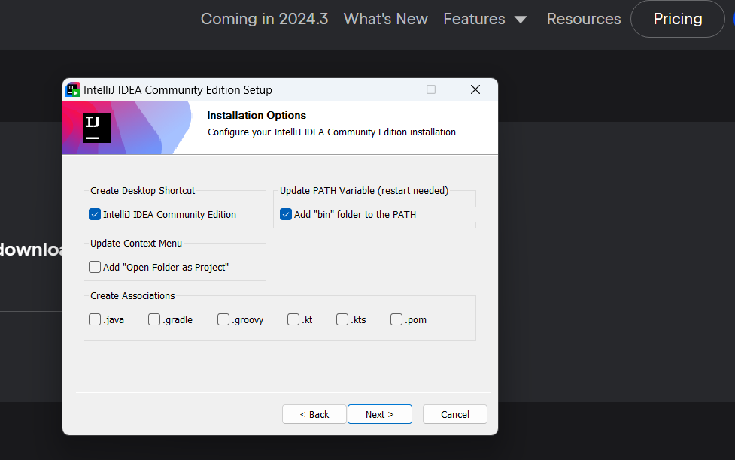

Create Github Account

Open <https://github.com>

Enter your email id

